PROTECTION AND PERMANENCY M EMORANDUM, 14-02

TO: Service Region Administrators
Service Region Administrator Associates
Service Region Clinical Associates
Regional Program Specialists
Family Services Office Supervisors

FROM: Tina Webb, Assistant Director
Division of Protection and Permanency

DATE: April 21, 2014

SUBJECT: Religious Affiliation of Children in Out of Home Care

Beginning July 1, 2014, all out of home care cases will be required to have the religious affiliation of the children field completed in TWIST. In preparation for this, staff will need update active cases with the information in the screen displayed below:

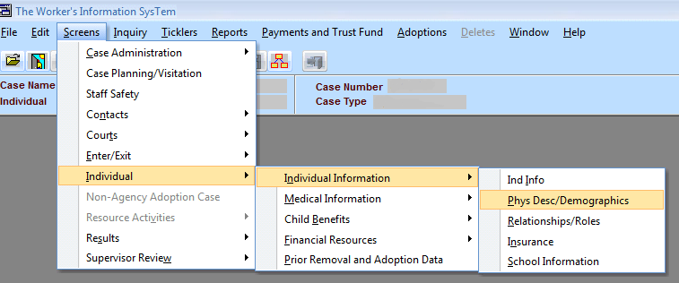

Once on the “Physical Description/Demographics” screen, please ensure that the following field is complete:

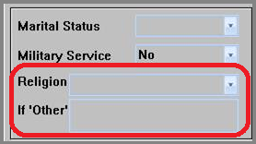

After July 1, 2014, this field will become mandatory for children in out of home care. If you have any questions regarding this memorandum, please contact via e-mail, jennie.willson@ky.gov or by telephone at (502) 564-2147, ext. 3608.

